Site Content Form - [Local Anesthetic Dosing Calculator]

I. TITLE CONTENT
Full Title | Local Anesthetic Dosing Calculator
Short Title | Local Anesthetic Calculator
Description | Determines the maximum safe dose of local anesthetics based on drug concentration and patient body weight
Short Description | Doses local anesthetics to help avoid toxic doses
Search Terms | Local anesthesia, local anesthetic systemic toxicity, LAST, nerve blocks, regional anesthesia, lidocaine, bupivacaine, ropivacaine, prilocaine, mepivacaine, fascial plane block, brachial plexus block
Calc ID

II. GROUPING
Function | Treatment, procedure
Condition | uncontrolled pain, planned surgical procedures, opioid-sparing
Specialty | Anesthesia, pain management, regional anesthesia, emergency medicine, plastic surgery, dermatology, dentistry, oral and maxillofacial surgery, interventional radiology, anesthesiology
Chief Complaint | Fracture, uncontrolled pain, planned surgical procedures, dislocations, acute pain, chronic pain, labor
Organ System | Nervous, musculoskeletal, cardiac, integumentary, vascular
Contributor(s) | John Paolo Palad, DO. Nicole Z Spence, MD, FASRA. William Caputo, MD
Reviewer(s) | Primary Specialty: Abbas Husain, Emergency Medicine

III. SEO
Meta Description | Local Anesthetic Dosing Calculator
Keywords | Local anesthesia, local anesthetic systemic toxicity, LAST, nerve blocks, regional anesthesia, lidocaine, bupivacaine, ropivacaine, prilocaine, mepivacaine, plane block, epidural, anesthetic infusion, toxicity dose, pediatric anesthetic dose
Alternate
For alpha/beta testing

IV. CONTRIBUTOR CONTENT
- BEFORE USE
Important | This calculator provides guidance for maximum dosing of local anesthetic and should not be used as the primary means of dosing. Always double check and err on the side of caution.  This calculator is not used for liposomal bupivacaine, which is bupivacaine designed in a slow-release injectable delivery system.
Instructions | There is ongoing debate about which body weight measurement best guides safe local anesthetic dosing. When using the patient’s actual body weight, patients at either end of the weight spectrum are more vulnerable to dosing errors.  Professional bodies, such as the American Society of Regional Anesthesia and Pain Medicine (ASRA) and the Society for Obesity and Bariatric Anaesthesia (SOBA), advise dosing based on lean body weight (LBW), particularly for patients with obesity. Other resources, such as the British National Formulary (BNF) and the Association of Anaesthetists’ normogram, use ideal body weight (IBW).  Regardless of the calculation method, clinicians should confirm that the final amount remains below the agent’s published maximum dose and remain vigilant for local anesthetic systemic toxicity.  Note: Previous versions of Goldfrank’s reported an increased maximum allowable dosage due to the vasoconstrictive effects of epinephrine when added to local anesthetics. The more recent version no longer includes this adjustment. Anesthesiology texts and clinical practice continue to report an increased maximum allowable dosage with lidocaine or mepivacaine. (Rosenberg 2004, Miller’s Anesthesia 10th Edition) Dosages should be double-checked and reviewed using your local pharmacy and policies.

- HOW TO USE
When to Use | Use the dosing calculator during procedures involving higher doses of local anesthetics (i.e. large laceration repairs, intradermal injections, nerve blocks, regional anesthesia) to reduce risk of toxicity and adverse effects including local anesthetic systemic toxicity (LAST).
Pearls/Pitfalls | The anesthetic toxic dose is based on ideal body weight.  Local anesthetic systemic toxicity (LAST) is rare but potentially life-threatening. Symptoms can be divided into two main categories:  - Neurotoxicity: perioral numbness, metallic taste, mental status changes or anxiety, visual changes, muscle twitching, and ultimately, seizures, coma, and respiratory depression.  - Cardiovascular toxicity: tachycardia, hypertension, ventricular arrhythmias, and/or asystole.  Patient risk factors for LAST include:  - Extremes of age.  - Decreased muscle mass.  - Renal, hepatic, or cardiac disease.  - Metabolic disturbances (acidosis, hypoxia, hypercarbia).  - Pregnancy.  Procedural risk factors for LAST include:  - Injection into highly vascular areas (highest incidence in paravertebral injections, followed by upper and lower extremity peripheral nerve blocks).  - Large laceration repairs and intradermal injections.  - Multiple injections or continuous infusion.  Ways to reduce the risk of LAST (Bailey 2025, On’Gele 2024):  - Calculate the patient's maximum dose.  - Dilution of anesthetic with normal saline allows for larger volume blocks to be performed without risking toxic doses.  - Vasoconstrictors, such as epinephrine, can be added to decrease rate of absorption and therefore decrease toxic dose.  - Use ultrasound to confirm needle placement.  - Aspirate prior to injecting.  - Perform a slow injection and look for appropriate anesthetic spread when using ultrasound guidance.  - Monitor for development of symptoms.
Why Use | It is important to appropriately dose local anesthetics and reduce the risk of LAST by calculating the maximum dose in advance to reduce risk.

- NEXT STEPS
Advice | - If the anesthetic dose is above the threshold for toxicity, consider lowering the dosage to the weight-determined range.  - Prepare for adverse events by having a nerve block checklist and having intralipid readily available and easy to access.
Management | LAST is an uncommon but potentially life-threatening complication of local anesthetic use that may be encountered in the ED, hospital, or surgical center. Patients at extremes of age or with organ dysfunction are at higher risk. Inadvertent intra-arterial or intravenous injection, as well as repeated doses and higher doses of local anesthetics are associated with greater risk of developing LAST. Using ultrasound guidance, aspirating prior to injection, and utilizing the minimal local anesthetic dose needed are techniques that can reduce the risk of LAST.  Diagnosing LAST:  Local anesthetic toxicity results from sodium channel blockade, which affects the central nervous system and cardiac system. The CNS is more sensitive to the effects of local anesthetics than the cardiac system and will generally manifest signs/symptoms of toxicity first.  The presenting symptoms of LAST include perioral numbness, metallic taste, mental status changes or anxiety, visual changes, muscle twitching, and ultimately, seizures, coma, and respiratory depression. Cardiovascular effects include tachycardia, hypertension, ventricular arrhythmias and/or asystole.  Management of LAST: (see guidelines: American Society of Regional Anesthesia and Pain Medicine Local Anesthetic Systemic Toxicity checklist: 2020 version)  Management of LAST requires immediate recognition and a coordinated response, starting with stopping the local anesthetic administration and calling for expert help while initiating a dedicated LAST protocol. Prioritize airway management, airway support with 100% oxygen or noninvasive ventilation, and support circulation according to advanced cardiac life support (ACLS) guidelines. Crucially, avoid calcium channel blockers, beta-blockers, and lidocaine, as they can worsen cardiovascular depression and toxicity; use epinephrine in smaller doses (< 1 mcg/kg) for LAST-induced shock. Seizures should be promptly controlled with benzodiazepines (e.g., midazolam, lorazepam), avoiding propofol which can exacerbate cardiovascular depression. For cardiovascular compromise, including hypotension and life-threatening arrhythmias, 20% lipid emulsion therapy is critical: administer an initial bolus (e.g., 1.5 mL/kg over 1 minute) followed by a continuous infusion (e.g., 0.25 mL/kg/min). Repeat boluses can be given after 5 minutes for 2 or more times for persistent hemodynamic instability. Vigorous resuscitation should continue until stability is achieved, followed by close monitoring in an intensive care setting.
Critical Actions | Multiple variables may influence a patient's risk of developing LAST. This weight-based calculator should be used to generate a rough estimate for toxic doses.

- EVIDENCE

Abstract | Determines the maximum safe dose of local anesthetics based on drug concentration and patient ideal or lean body weight
Evidence Appraisal | There are no randomized clinical trials involving LAST. Much of the existing evidence is based on case reports, expert opinion, and retrospective anesthesia databases.
Formula | Max allowable subQ dose based on ideal body weight, mg = max allowable subQ dose for a drug, mg/kg × weight, kg  Max allowable subQ dose based on ideal body weight, mL = max allowable subQ dose for a drug, mg/kg × (weight, kg / 10) × (1 / concentration, %)
Facts & Figures | 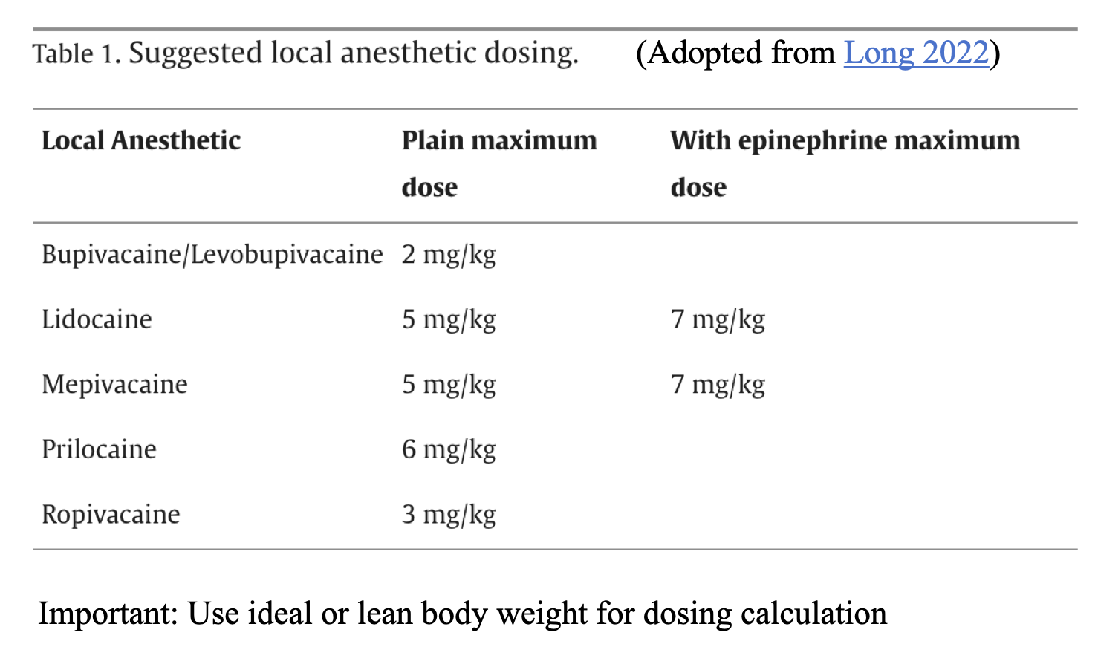
Literature | There are no randomized clinical trials involving LAST. Much of the existing evidence is based on case reports, expert opinion, and retrospective anesthesia databases.  Original/Primary & Validation:  -Sztajnkrycer MD. Local Anesthetics. In: Hoffman RS, Howland M, Lewin NA, Nelson LS, Goldfrank LR. eds. Goldfrank’s Toxicologic Emergencies, 11e New York, NY: McGraw-Hill; 2019.  Clinical Practice Guidelines  - AAGBI Safety Guideline. Management of Severe Local Anaesthetic Toxicity. https://anaesthetists.org/Home/Resources-publications/Guidelines/Archived-guidelines/Management-of-severe-local-anaesthetic-toxicity  - Neal JM, Barrington MJ, Fettiplace MR, et al. The Third American Society of Regional Anesthesia and Pain Medicine Practice Advisory on Local Anesthetic Systemic Toxicity: Executive Summary 2017. Reg Anesth Pain Med. 2018;43(2):113-123.  - Lavonas EJ, Akpunonu PD, Arens AM, Babu KM, Cao D, Hoffman RS, Hoyte CO, Mazer-Amirshahi ME, Stolbach A, St-Onge M, Thompson TM, Wang GS, Hoover AV, Drennan IR; American Heart Association. 2023 American Heart Association Focused Update on the Management of Patients With Cardiac Arrest or Life-Threatening Toxicity Due to Poisoning: An Update to the American Heart Association Guidelines for Cardiopulmonary Resuscitation and Emergency Cardiovascular Care. Circulation. 2023 Oct 17;148(16):e149-e184. doi: 10.1161/CIR.0000000000001161.  Other References:  -Schwartz DR, Kaufman B. Local Anesthetics. In: Hoffman RS, Howland M, Lewin NA, Nelson LS, Goldfrank LR. eds. Goldfrank's Toxicologic Emergencies, 10e. McGraw-Hill Education; 2015.  -Rosenberg PH, Veering BT, Urmey WF. Maximum recommended doses of local anesthetics: a multifactorial concept. Reg Anesth Pain Med. 2004 Nov-Dec;29(6):564-75; discussion 524. doi: 10.1016/j.rapm.2004.08.003. PMID: 15635516.  -Miller's Anesthesia: Local Anesthesia: 10th Edition, chapter 25: Gropper, M. A., Cohen, N. H., Eriksson, L. I., Fleisher, L. A., Leslie, K., & Johnson-Akeju, O. (Eds.). (2025). Local anesthetics (Chap. 25, p742-767) in Miller’s anesthesia (10th ed.). Elsevier.  -Bailey JG, Barry G, Volk T. Local anesthetic dosing for fascial plane blocks to avoid systemic toxicity: a narrative review. Can J Anaesth. 2025;72(9):1423-1447.  -On'Gele MO, Weintraub S, Qi V, Kim J. Local Anesthetics, Local Anesthetic Systemic Toxicity (LAST), and Liposomal Bupivacaine. Anesthesiol Clin. 2024 Jun;42(2):303-315. doi: 10.1016/j.anclin.2023.11.011.  -Neal JM, Neal EJ, Weinberg GL. American Society of Regional Anesthesia and Pain Medicine Local Anesthetic Systemic Toxicity checklist: 2020 version. Reg Anesth Pain Med. 2021 Jan;46(1):81-82. doi: 10.1136/rapm-2020-101986.  -Long B, Chavez S, Gottlieb M, Montrief T, Brady WJ. Local anesthetic systemic toxicity: A narrative review for emergency clinicians. Am J Emerg Med. 2022 Sep;59:42-48. doi: 10.1016/j.ajem.2022.06.017

E. FROM THE CREATOR
Creator name | John Paolo Palad, DO. Nicole Z Spence, MD, FASRA,William Caputo, MD
Creator Interview

F. ADDITIONAL CONTENT

Short Form Content | -ASRA Local Anesthetic Systemic Toxicity Checklist: https://asra.com/docs/default-source/guidelines-articles/local-anesthetic-systemic-toxicity-rgb.pdf?sfvrsn=33b348e_2  -Internet Book of Critical Care (IBCC) : Local Anesthetic Systemic Toxicity (LAST). https://emcrit.org/ibcc/last/

